🏥 Doctor Appointment Chatbot – Final Document
1. 📋 Requirements
- Functional: Natural language booking, availability check, appointment confirmation.
- Technical: Flask backend, OpenAI GPT (or mocked), SQLite DB, Postman/curl testing, virtual environment.
2. Sequence Diagram (UML Style)

@startuml
actor Patient
participant "Flask API (/chat)" as Flask
participant "Chatbot Logic" as Chatbot
participant "OpenAI API" as OpenAI
participant "Tools Layer" as Tools
database "SQLite Database" as DB

Patient -> Flask: Send message ("Book Dr. X tomorrow at 10 AM")
Flask -> Chatbot: interpret_message(user_message)
Chatbot -> OpenAI: NLP intent detection
OpenAI --> Chatbot: Extracted intent + entities
Chatbot -> Tools: check_availability(doctor, date, time)
Tools -> DB: Query availability
DB --> Tools: Availability result
Tools -> Flask: Return availability/booking result
Flask -> Patient: JSON response (confirmation or alternative slot)
@enduml
🧩 Explanation of Flow
- Patient → Flask API The patient sends a natural language request (e.g., “Book Dr. X tomorrow at 10 AM”) to the chatbot endpoint /chat.
- Flask → Chatbot Logic The Flask backend passes the message to chatbot.py for interpretation.
- Chatbot → OpenAI API The chatbot uses OpenAI GPT to detect intent (appointment booking) and extract entities (doctor name, date, time).
- OpenAI → Chatbot The AI returns structured information about the request.
- Chatbot → Tools Layer Based on the intent, the chatbot calls tools.py functions (check_availability, book_appointment).
- Tools → Database The tools query the SQLite database (clinic.db) to check if the requested slot is available.
- Database → Tools → Flask The database returns results. Tools update booking if available and send the outcome back to Flask.
- Flask → Patient Flask sends a JSON response to the patient: either a booking confirmation or an alternative suggestion.
📊 Activity Diagram (UML Style)
Code
@startuml
start

:Patient sends request ("Book Dr. X tomorrow at 10 AM");

:Flask API receives request;
:Passes message to Chatbot Logic;

:Chatbot interprets intent (via OpenAI or mock);

if (Intent = Booking?) then (yes)
:Extract doctor, date, time;
:Call Tools Layer -> check_availability;
if (Slot Available?) then (yes)
:Book appointment;
:Update database (status = Booked);
:Return confirmation message;
else (no)
:Suggest alternative slot;
:Return availability message;
endif
else (no)
:Return general chatbot reply;
endif

stop
@enduml
🧩 Explanation of Flow
- Start: Patient sends a natural language request.
- Flask API: Receives the request and forwards it to the chatbot logic.
- Chatbot Logic: Uses OpenAI (or mocked response) to interpret intent.
- Decision Point – Intent:
  - If the intent is booking, extract doctor, date, and time.
  - If not, return a general chatbot reply.
- Decision Point – Availability:
  - If the slot is available → book appointment, update database, return confirmation.
  - If not available → suggest an alternative slot, return availability message.
- End: Patient receives a JSON response with either confirmation or guidance.
🏗️ Architecture Diagram (UML)
Code
@startuml
actor Patient

rectangle "Frontend (UI)" {
Patient
}

rectangle "Backend (Flask API)" {
component "app.py" as Flask
}

rectangle "Chatbot Logic" {
component "chatbot.py" as Chatbot
}

rectangle "Tools Layer" {
component "tools.py" as Tools
}

database "SQLite Database" as DB

Patient --> Flask : Send request (/chat)
Flask --> Chatbot : interpret_message()
Chatbot --> Tools : Call check_availability / book_appointment
Tools --> DB : Query / Update slots
DB --> Tools : Return results
Tools --> Flask : Booking outcome
Flask --> Patient : JSON response
@enduml
🧩 Explanation of Architecture
- Frontend (UI)
  - The patient interacts with the chatbot via Postman, curl, or a web interface.
  - Requests are sent to the backend API.
- Backend (Flask API – app.py)
  - Provides REST endpoints (/chat).
  - Acts as the entry point for all patient requests.
  - Routes messages to the chatbot logic.
- Chatbot Logic (chatbot.py)
  - Interprets user messages using OpenAI GPT (or mocked responses if credits are exhausted).
  - Extracts intent (e.g., booking) and entities (doctor, date, time).
  - Decides whether to call tools for availability/booking.
- Tools Layer (tools.py)
  - Encapsulates business logic for checking availability and booking appointments.
  - Ensures database operations are consistent and reusable.
- Database Layer (SQLite – clinic.db)
  - Stores doctors, availability slots, and appointments.
  - Responds to queries and updates triggered by the tools layer.
- Response Flow
  - Results flow back through tools → chatbot → Flask → patient.
  - Patient receives a JSON response with confirmation or guidance
4. ⚙️ Installation Steps
- Create project structure.
- Setup venv → python -m venv venv.
- Activate venv → venv\Scripts\activate.
- Install dependencies → pip install -r requirements.txt.
- Create .env with OPENAI_API_KEY.
- Run python db_setup.py → seeds database.
- Run python app.py → starts Flask server.
- Test with Postman or PowerShell.
5. 🛠️ Implementation Code
requirements.txt
flask
openai
requests
python-dotenv
db_setup.py
import sqlite3

def init_db():
conn = sqlite3.connect("clinic.db")
cursor = conn.cursor()

cursor.execute("""CREATE TABLE IF NOT EXISTS doctors (
id INTEGER PRIMARY KEY AUTOINCREMENT,
name TEXT, specialty TEXT)""")

cursor.execute("""CREATE TABLE IF NOT EXISTS availability (
id INTEGER PRIMARY KEY AUTOINCREMENT,
doctor_id INTEGER, date TEXT, time TEXT, status TEXT)""")

cursor.execute("""CREATE TABLE IF NOT EXISTS appointments (
id INTEGER PRIMARY KEY AUTOINCREMENT,
doctor_id INTEGER, patient_name TEXT, date TEXT, time TEXT, status TEXT)""")

# Seed sample data
cursor.execute("INSERT INTO doctors (name, specialty) VALUES ('Dr. X', 'Orthopedic')")
cursor.execute("INSERT INTO doctors (name, specialty) VALUES ('Dr. Y', 'Dermatologist')")
cursor.execute("INSERT INTO availability (doctor_id, date, time, status) VALUES (1, '2026-09-01', '10:00', 'Available')")
cursor.execute("INSERT INTO availability (doctor_id, date, time, status) VALUES (2, '2026-09-01', '11:00', 'Available')")

conn.commit()
conn.close()

if __name__ == "__main__":
init_db()
tools.py
import sqlite3
conn = sqlite3.connect("clinic.db", check_same_thread=False)
cursor = conn.cursor()

def check_availability(doctor_name, date, time):
cursor.execute("""SELECT * FROM availability a
JOIN doctors d ON a.doctor_id=d.id
WHERE d.name=? AND a.date=? AND a.time=? AND a.status='Available'""",
(doctor_name, date, time))
return cursor.fetchone()

def book_appointment(doctor_name, patient_name, date, time):
cursor.execute("SELECT id FROM doctors WHERE name=?", (doctor_name,))
doctor_id = cursor.fetchone()[0]
cursor.execute("""UPDATE availability SET status='Booked'
WHERE doctor_id=? AND date=? AND time=?""",
(doctor_id, date, time))
cursor.execute("""INSERT INTO appointments (doctor_id, patient_name, date, time, status)
VALUES (?, ?, ?, ?, 'Booked')""",
(doctor_id, patient_name, date, time))
conn.commit()
return f"Appointment booked with {doctor_name} for {patient_name} on {date} at {time}"
chatbot.py
python
import os
from dotenv import load_dotenv
from openai import OpenAI

load_dotenv()
api_key = os.getenv("OPENAI_API_KEY")

client = None
if api_key:
client = OpenAI(api_key=api_key)

def interpret_message(user_message):
if not client:
# Mock response if no credits
return f"(Mock reply) You said: {user_message}"
try:
response = client.chat.completions.create(
model="gpt-4.1",
messages=[
{"role": "system", "content": "You are Doctor’s Assistant for Super Clinic."},
{"role": "user", "content": user_message}
]
)
return response.choices[0].message.content
except Exception as e:
return f"(Error or quota issue) {str(e)}"
app.py
python
from flask import Flask, request, jsonify
from chatbot import interpret_message
from tools import check_availability, book_appointment

app = Flask(__name__)

@app.route("/chat", methods=["POST"])
def chat():
user_message = request.json["message"]
reply = interpret_message(user_message)

# Simple intent detection
if "book" in user_message.lower():
result = book_appointment("Dr. X", "Patient A", "2026-09-01", "10:00")
return jsonify({"reply": reply, "action": result})

return jsonify({"reply": reply})

if __name__ == "__main__":
app.run(debug=True)
test.py
python
import requests

url = "http://127.0.0.1:5000/chat"
data = {"message": "I want to book Dr. X tomorrow at 10 AM"}

response = requests.post(url, json=data)
print(response.json())
6. 🧪 Testing
- Start server: python app.py
- PowerShell:
powershell
Invoke-WebRequest -Uri "http://127.0.0.1:5000/chat" -Method POST -ContentType "application/json" -Body '{"message":"I want to book Dr. X tomorrow at 10 AM"}'
- Postman: POST → http://127.0.0.1:5000/chat → JSON body.
{
"message": "which dermatologists are available in bhubaneswar "
}

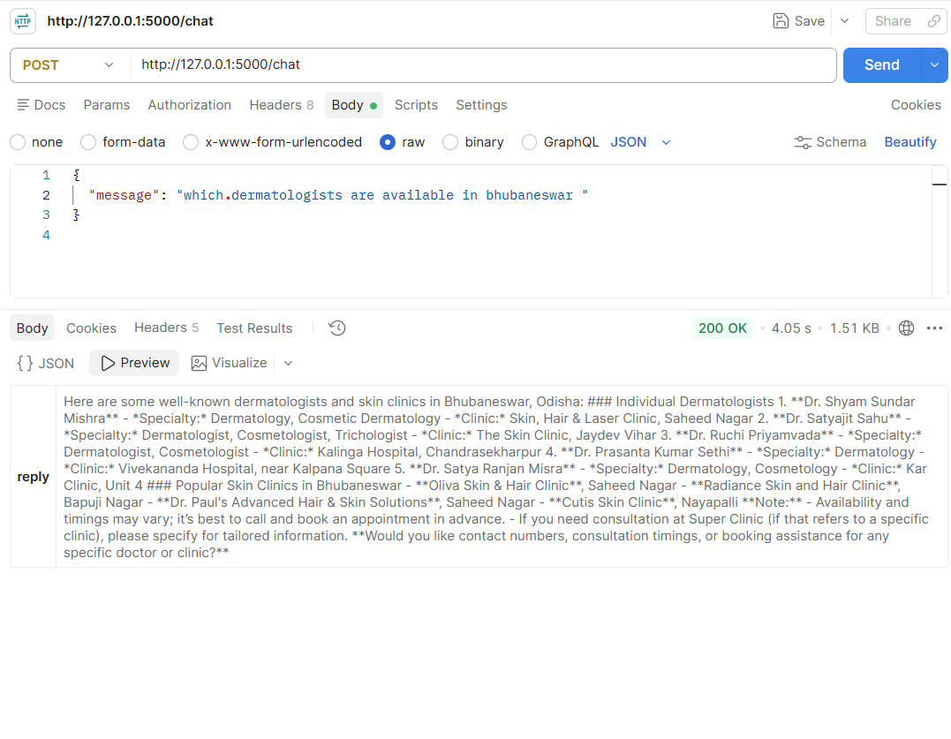
- Python script: python test.py.
7. 🛑 Issues & Fixes
- Flask not found → pip install flask.
- dotenv not found → pip install python-dotenv.
- ECONNREFUSED → Flask server not running.
- RateLimitError (429) → Add credits OR mock responses.

